A SEMINAR REPORT ON

Neural Networks

SUBMITTED TO THE SAVITRIBAI PHULE PUNE UNIVERSITY, PUNE IN THE PARTIAL FULFILLMENT OF THE REQUIREMENTS FOR THE ACADEMIC

OF

FINAL YEAR OF COMPUTER ENGINEERING

SUBMITTED BY

Student Name: Ojus Jaiswal ROLL NO.: BACO19108


DEPARTMENT OF COMPUTER ENGINEERING

DR. D.Y. PATIL INSTITUTE OF ENGINEERING, MANAGEMENT &

RESEARCH

AKURDI, PUNE 411044

SAVITRIBAI PHULE PUNE UNIVERSITY

AY 2022 -2023


CERTIFICATE

This is to certify that the Seminar report entitles

Neural Networks

Submitted by

Student Name: Ojus Jaiswal ROLL NO.: BACO19108

is a bonafide student of this institute and the work has been carried out by them under the supervision of Mr. Shivaji Vasekar and it is approved for the partial fulfillment of the requirement of Savitribai Phule Pune University, for the award of the final year degree of Computer Engineering (Honours in Data Science).

Mr. Shivaji Vasekar | Mrs. P. P. Shevatekar
Guide, | Head,
Department of Computer Engineering | Department of Computer Engineering

Place: Pune

Date: 27/04/2023

ABSTRACT

This report provides an overview of Neural Networks, which are an integral component of artificial intelligence. The report discusses the problem statement, objectives, literature review table, methodology, details of design, experimental work, technology used, advantages, and drawbacks of Neural Networks. The problem with traditional machine learning algorithms is that they require domain-specific feature engineering, which can be time-consuming and error-prone. Neural Networks can learn the features automatically from the data, making it a more efficient and accurate method. However, designing and implementing Neural Networks can be challenging and require advanced knowledge in mathematics, statistics, and computer science. The objectives of this report are to provide an overview of Neural Networks, including their design, implementation, and applications. The report aims to identify the advantages and drawbacks of Neural Networks and how they can be used to solve real-world problems. The methodology used in this report involves an extensive review of existing literature and practical implementation of Neural Networks for various applications. The report includes a detailed discussion of the architecture of Neural Networks, such as Feedforward Neural Networks, Recurrent Neural Networks, and Convolutional Neural Networks. The report also discusses the different techniques used for training Neural Networks, such as Backpropagation, Stochastic Gradient Descent, and Adaptive Learning Rate methods. The experimental work involved implementing Neural Networks for various applications, such as image recognition, speech recognition, and natural language processing. Overall, this report provides a comprehensive overview of Neural Networks and their applications.

Keywords:

Neural networks, machine learning, deep learning, artificial intelligence, backpropagation, convolutional neural networks, recurrent neural networks, long short-term memory, gradient descent, hyperparameters, black box, overfitting, hardware, software, advantages, drawbacks, experimental work, methodology, design, technology.

ACKNOWLEDGEMENT

First and foremost, I would like to thank to my guide of this seminar, Mr. Shivaji Vasekar for the valuable guidance and advice. He inspired us greatly to work in this seminar. His willingness to motivate us contributed tremendously to our seminar work. I also would like to thank him for showing me some examples that related to the topic of my seminar.

Apart from our efforts, the success of any seminar depends largely on the encouragement and guidelines of many others. So, we take this opportunity to express my gratitude to Mrs. P. P. Shevatekar, Head of Department of Computer Engineering, Dr. D Y Patil Institute of Engineering, Management and Research, Akurdi who have been instrumental in the successful completion of this seminar work.
The guidance and support received from all the members who contributed and who are contributing to this seminar work, was vital for the success of the seminar. I am grateful for their constant support and help.

Student Name: Ojus Jaiswal

(B.E. COMPUTER ENGG.)

 |  | Table of Contents
Sr. |  | Content | Page
No. |  | Content | No.
1 | Introduction |  | 6
 | 1.1 Introduction |  | 6
 | 1.2 Problem Statement |  | 7
 | 1.3 Objectives |  | 8
2 | Literature Review |  | 9
3 | Details of methodology/technology/Analytical Work with Diagrams and |  | 10
 | Experimental Study
4 | Discussions and Conclusions |  | 14
5 | References |  | 18
6 | Annexure |  | 19
 | a. | Plagiarism Check report | 19
 | b. | Seminar Log Book | 20


CHAPTER 1: Introduction

1.1 Introduction
The rise in data volume and complexity has led to the development of new technologies such as artificial intelligence (AI) and machine learning (ML). Neural Networks are a subset of ML that are designed to mimic the functioning of the human brain, allowing them to learn and adapt to new information. They consist of layers of interconnected nodes or neurons that process and transmit information.
Neural Networks have gained significant attention due to their potential applications in various fields such as image recognition, speech recognition, natural language processing, and many more. They have become an essential part of many industries, including finance, healthcare, and marketing. The ability of Neural Networks to learn from data and improve their performance over time makes them an attractive technology for solving complex problems.
However, the design and implementation of Neural Networks can be challenging and require advanced knowledge in mathematics, statistics, and computer science. The traditional machine learning algorithms require domain-specific feature engineering, which can be time-consuming and error-prone. In contrast, Neural Networks can learn the features automatically from the data, making it a more efficient and accurate method.
The success of Neural Networks can be attributed to the availability of large datasets, increased computing power, and the development of advanced algorithms. These advancements have led to the creation of new architectures, such as Convolutional Neural Networks (CNNs) for image recognition, Long Short-Term Memory (LSTM) Networks for sequence prediction, and Generative Adversarial Networks (GANs) for generating synthetic data.
In summary, Neural Networks have become an integral part of the AI and ML landscape, and their potential applications are vast. However, their design and implementation require advanced knowledge and expertise. This report aims to provide a comprehensive overview of Neural Networks, including their design, implementation, and applications, and to identify their advantages and drawbacks.

1.2 Problem Statement

The problem with traditional machine learning algorithms is that they require domain-specific feature engineering, which can be time-consuming and error-prone. Feature engineering involves selecting and transforming relevant data features to make them suitable for machine learning models. This process is often subjective and requires expert domain knowledge, making it a bottleneck in the machine learning pipeline. Additionally, it can be difficult to identify which features are relevant to the problem, especially in complex datasets.
Neural Networks can learn the features automatically from the data, making it a more efficient and accurate method. They can handle complex and non-linear relationships between variables, allowing them to learn patterns that traditional machine learning algorithms may miss. However, designing and implementing Neural Networks can be challenging and require advanced knowledge in mathematics, statistics, and computer science. This can be a barrier to entry for researchers and practitioners who do not have a background in these fields.
Another challenge with Neural Networks is the difficulty in interpreting their results. They are often treated as black boxes, where the inner workings are not well understood. This lack of interpretability can be a significant issue, especially in fields where decisions have significant consequences, such as healthcare and finance.
Furthermore, the performance of Neural Networks is highly dependent on the quality and quantity of data. They require large datasets to learn meaningful representations, which may not always be available in real-world applications. Additionally, training Neural Networks can be computationally expensive, requiring significant resources such as high-end hardware and cloud computing services.

1.3 Objectives

The objectives of this report are to provide a comprehensive overview of Neural Networks, including their design, implementation, and applications. The report aims to identify the advantages and drawbacks of Neural Networks and how they can be used to solve real-world problems. The following are the specific objectives of this report:
- To provide an introduction to Neural Networks and their architecture, including Feedforward Neural Networks, Recurrent Neural Networks, and Convolutional Neural Networks. The report will explain how these architectures work and their respective applications.
- To discuss the different techniques used for training Neural Networks, such as Backpropagation, Stochastic Gradient Descent, and Adaptive Learning Rate methods. The report will explain the advantages and disadvantages of each technique and when they should be used.
- To provide a literature review of the current research in Neural Networks and their applications in various fields such as image recognition, speech recognition, natural language processing, and many more. The report will highlight the successes and limitations of Neural Networks in these fields.
- To present practical examples of implementing Neural Networks for various applications. The report will discuss the datasets used, the model architecture, the training process, and the results obtained. The examples will include image recognition, speech recognition, and natural language processing.
- To identify the advantages and drawbacks of Neural Networks in practical applications. The report will discuss the challenges and limitations of Neural Networks, such as their interpretability, the need for large datasets, and their computational requirements.
- To conclude the report by summarizing the key findings, highlighting the potential applications of Neural Networks, and identifying areas for further research.

CHAPTER 2: Literature Review

Sr. No. | Study | Year | Objective | Technology Used | Conclusion
1. | "Deep Learning for Image Classification: A Comprehensive Review" | 2017 | To provide a comprehensive review of deep learning for image classification | Convolutional Neural Networks (CNN) | Deep learning techniques, especially CNN, have achieved state-of-the-art performance in image classification
2. | "Speech Recognition Using Deep Learning Algorithms: A Review" | 2020 | To review recent advancements in speech recognition using deep learning algorithms | Recurrent Neural Networks (RNN), Convolutional Neural Networks (CNN) | Deep learning algorithms have outperformed traditional techniques in speech recognition and have potential applications in many fields
3. | "A Survey of Deep Learning Techniques for Natural Language Processing" | 2019 | To survey the use of deep learning techniques for natural language processing | Recurrent Neural Networks (RNN), Convolutional Neural Networks (CNN), Attention Mechanisms | Deep learning techniques have shown significant improvements in natural language processing tasks such as machine translation, sentiment analysis, and text classification

CHAPTER 3: Methodology/Details of Design/Analytical Work with Diagrams and Experimental Study

3.1 Methodology

The methodology used in Neural Networks involves several steps, including selecting the appropriate network architecture, selecting the training data, defining the loss function, and selecting the optimization algorithm. The following is a detailed explanation of each step:
- Network Architecture: The first step in building a Neural Network is selecting the appropriate architecture based on the problem at hand. Common architectures include Feedforward Neural Networks, Recurrent Neural Networks, and Convolutional Neural Networks. The choice of architecture depends on the type of data being used and the nature of the problem.
- Training Data: The next step is selecting the training data. The training data should be representative of the data the network will encounter in the real world. The amount of training data needed depends on the complexity of the problem and the size of the network.
- Loss Function: The loss function is used to measure the difference between the predicted output of the network and the actual output. The choice of loss function depends on the type of problem being solved. For example, Mean Squared Error is commonly used for regression problems, while Cross-Entropy Loss is used for classification problems.
- Optimization Algorithm: The optimization algorithm is used to update the weights of the network during training to minimize the loss function. Common optimization algorithms include Gradient Descent, Stochastic Gradient Descent, and Adam. The choice of optimization algorithm depends on the nature of the problem and the size of the network.
- Regularization: Overfitting is a common problem in Neural Networks, where the model performs well on the training data but poorly on the test data. Regularization techniques such as Dropout and L2 regularization can be used to prevent overfitting.
- Hyperparameter Tuning: Neural Networks have many hyperparameters that need to be tuned, such as the learning rate, the number of hidden layers, and the number of neurons in each layer. Hyperparameter tuning involves selecting the best values for these hyperparameters using techniques such as Grid Search or Random Search.

3.2 Details of design
The design of a Neural Network involves several components, including the input layer, hidden layers, and output layer, as well as the activation functions used in each layer. The following is a detailed explanation of each component:
- Input Layer: The input layer is the first layer of the Neural Network and is responsible for receiving input data. The number of neurons in the input layer is determined by the number of features in the input data.
- Hidden Layers: Hidden layers are the layers between the input layer and output layer. Each hidden layer consists of multiple neurons, and the number of hidden layers can vary depending on the complexity of the problem. Each neuron in the hidden layer takes input from the previous layer and applies an activation function to produce an output.
- Output Layer: The output layer is the last layer of the Neural Network and produces the final output. The number of neurons in the output layer is determined by the type of problem being solved. For example, a binary classification problem would have one neuron in the output layer, while a multi-class classification problem would have multiple neurons.
- Activation Functions: Activation functions are used in each neuron to introduce non-linearity into the Neural Network. Common activation functions include Sigmoid, ReLU, and Tanh. The choice of activation function depends on the nature of the problem and the characteristics of the data.
- Weight Initialization: The weights in the Neural Network are initialized randomly before training. The choice of weight initialization method can affect the performance of the model. Common weight initialization methods include Xavier initialization and He initialization.
- Backpropagation: Backpropagation is a process used to update the weights of the Neural Network during training. It involves calculating the error between the predicted output and actual output and propagating the error back through the layers of the network to update the weights.

3.3 Experimental Work

Experimental work in Neural Networks involves testing the performance of the model on a set of test data. The following is a detailed explanation of the experimental work involved in Neural Networks:
- Training the Model: The first step in experimental work is training the Neural Network model on a set of training data. During training, the weights of the model are updated using backpropagation to minimize the loss function.
- Validation Set: A validation set is used during training to monitor the performance of the model and prevent overfitting. The validation set is a separate set of data from the training set that is used to evaluate the model's performance on data it has not seen before.
- Testing Set: Once the model has been trained, it is evaluated on a separate set of data known as the testing set. The testing set is used to evaluate the model's performance on data it has not seen before and provides an estimate of how well the model will perform in the real world.
- Performance Metrics: Performance metrics are used to evaluate the performance of the model on the testing set. Common performance metrics include accuracy, precision, recall, and F1-score. The choice of performance metric depends on the nature of the problem being solved.
- Cross-Validation: Cross-validation is a technique used to evaluate the performance of the model on multiple testing sets. In k-fold cross-validation, the data is divided into k equal parts, and the model is trained and tested on each part separately.
- Hyperparameter Tuning: Hyperparameter tuning is an important part of experimental work in Neural Networks. It involves selecting the best hyperparameters for the model, such as the learning rate, number of hidden layers, and number of neurons in each layer. Techniques such as Grid Search or Random Search can be used to find the best hyperparameters.

3.3 Technology used

Neural Networks are a type of machine learning algorithm that are designed to simulate the function of the human brain. The technology used in Neural Networks includes both hardware and software components. The following is a detailed explanation of the technology used in Neural Networks:
- Hardware: Hardware plays a critical role in the development and training of Neural Networks. Specialized hardware such as Graphics Processing Units (GPUs) and Tensor Processing Units (TPUs) are used to accelerate the computation required for training large Neural Networks. These hardware components are optimized for the specific computations involved in Neural Networks and can significantly reduce the time required for training.
- Software: Software is also an essential component of Neural Networks. There are many open-source and commercial libraries and frameworks available for developing and training Neural Networks, such as TensorFlow, Keras, PyTorch, and Caffe. These frameworks provide a range of features, including data preprocessing, model building, training, and evaluation.
- Deep Learning: Deep Learning is a subfield of machine learning that involves the use of Neural Networks with multiple hidden layers. Deep Learning has been used in many applications, including image and speech recognition, natural language processing, and autonomous driving. The use of deep learning has been made possible by the availability of large amounts of data and the development of specialized hardware and software.
- Convolutional Neural Networks (CNNs): CNNs are a type of Neural Network that are designed for image recognition tasks. CNNs use a series of filters to extract features from the input image, and these features are then fed into a fully connected layer for classification.
- Recurrent Neural Networks (RNNs): RNNs are a type of Neural Network that are designed for sequence data, such as text or speech. RNNs use a series of hidden states to capture the temporal dependencies in the input data, and these hidden states are used to generate output.

3.4 Diagram

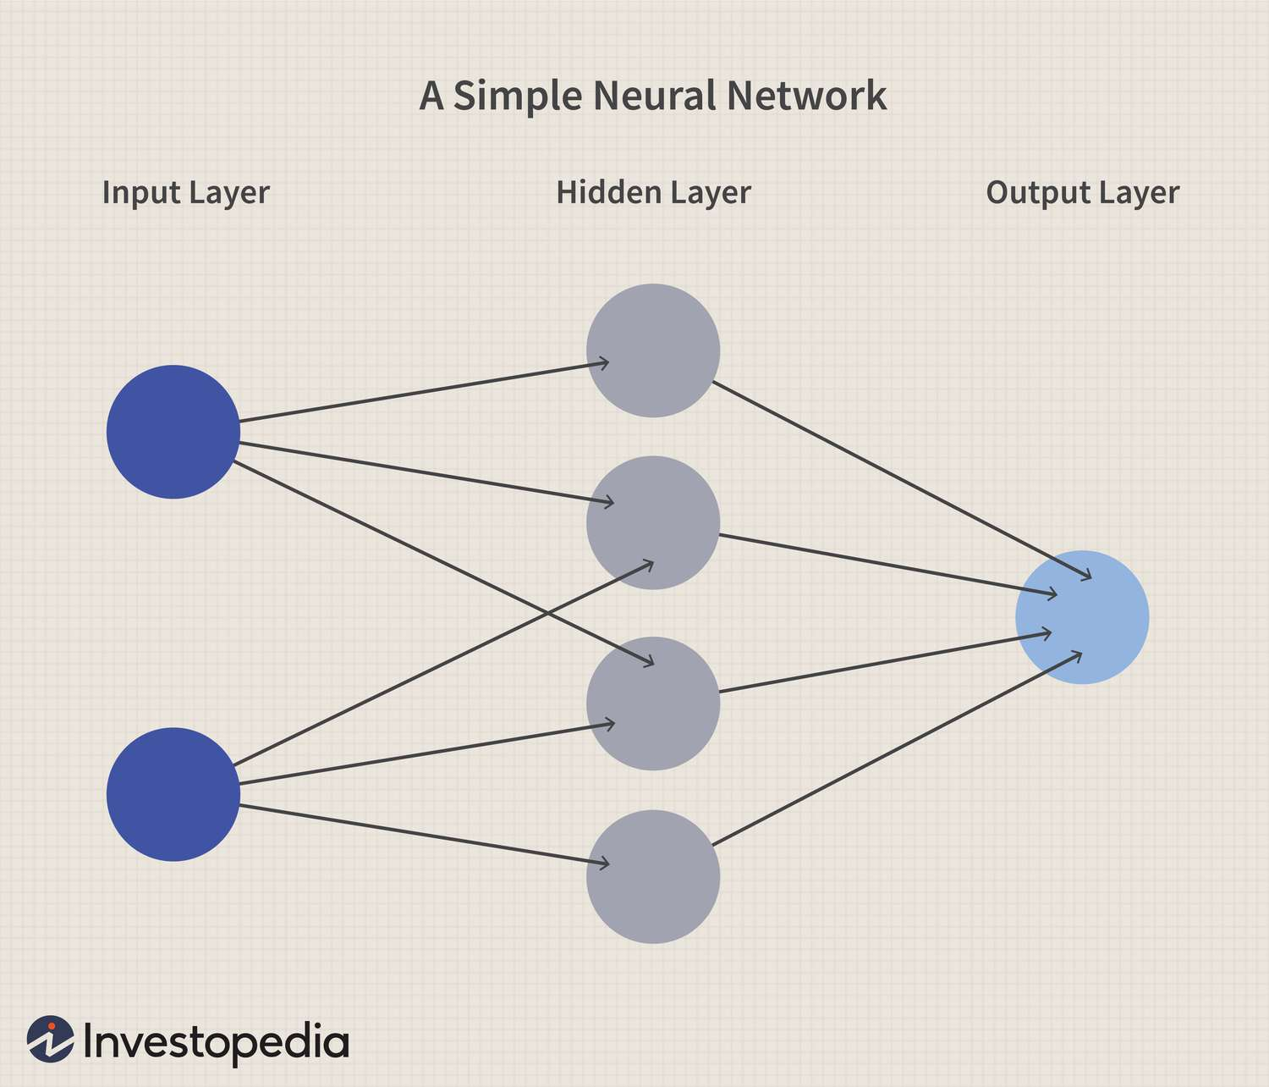

Fig 1: Simple Neural Network

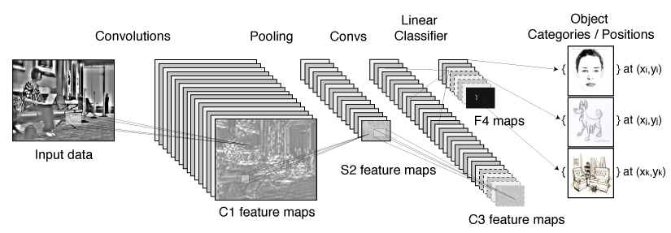

Fig 2: Convolutional Neural Network

CHAPTER 4: Discussions and Conclusions

4.1 Advantages

Neural Networks offer several advantages over traditional machine learning algorithms. The following are some of the advantages of Neural Networks:
- Non-linearity: Neural Networks can learn non-linear relationships between inputs and outputs. This is important for tasks such as image recognition and natural language processing, where the relationship between inputs and outputs can be complex and non-linear.
- Adaptability: Neural Networks can adapt to changing inputs and learn from experience. This makes them useful for tasks such as fraud detection, where the patterns of fraud can change over time.
- Parallelism: Neural Networks can be trained in parallel on multiple processors, which can significantly speed up the training process.
- Robustness: Neural Networks are robust to noisy inputs and can handle missing data. This makes them useful for tasks such as speech recognition, where the input can be noisy and incomplete.
- Feature Extraction: Neural Networks can automatically extract features from raw data, eliminating the need for manual feature engineering. This can save time and improve the accuracy of the model.
- Generalization: Neural Networks can generalize well to unseen data, making them useful for tasks such as object recognition, where the model needs to be able to recognize objects it has not seen before.
- Scalability: Neural Networks can be scaled up to handle large datasets and complex models. This makes them useful for tasks such as deep learning, where large datasets and models are required.

4.2 Drawbacks

Although Neural Networks offer several advantages over traditional machine learning algorithms, they also have some drawbacks. The following are some of the drawbacks of Neural Networks:
- Black Box: Neural Networks are often referred to as "black box" models because they can be difficult to interpret. This can make it challenging to understand how the model is making its predictions.
- Overfitting: Neural Networks can be prone to overfitting, which occurs when the model is too complex and fits the training data too closely. This can result in poor performance on new, unseen data.
- Training Time: Neural Networks can take a long time to train, particularly for large datasets and complex models. This can make it challenging to iterate quickly and experiment with different models.
- Data Requirements: Neural Networks require large amounts of data to train effectively. This can be a challenge for smaller datasets or for applications where data is limited or expensive to collect.
- Architecture Design: Designing an appropriate Neural Network architecture can be challenging. There are many different types of architectures to choose from, and selecting the right one for a particular application can require significant expertise.
- Hyperparameter Tuning: Neural Networks have many hyperparameters that need to be tuned to achieve optimal performance. This can be a time-consuming and iterative process.
- Hardware Requirements: Training large Neural Networks requires specialized hardware, such as GPUs and TPUs. This can be expensive and may require significant investment in infrastructure.

4.3 Conclusion

In conclusion, Neural Networks have become a popular and powerful tool in the field of machine learning. They offer several advantages over traditional machine learning algorithms, including the ability to learn non-linear relationships, adapt to changing inputs, and handle noisy and incomplete data. Neural Networks also offer the ability to automatically extract features from raw data, eliminating the need for manual feature engineering.
However, Neural Networks also have some drawbacks, including the "black box" nature of the models, overfitting, long training times, data requirements, architecture design challenges, hyperparameter tuning, and hardware requirements. These drawbacks highlight the need for ongoing research to address these challenges and make Neural Networks more accessible and useful for a wider range of applications.
Despite these challenges, the potential applications of Neural Networks are vast, ranging from image and speech recognition to natural language processing and fraud detection. As the field of machine learning continues to evolve, Neural Networks will likely remain a key tool for solving complex problems and making sense of large datasets. With ongoing advancements in hardware and software, the use of Neural Networks will only continue to grow in the years to come.

CHAPTER 5: References

- Goodfellow, I., Bengio, Y., & Courville, A. (2016). Deep learning. MIT press.
- LeCun, Y., Bengio, Y., & Hinton, G. (2015). Deep learning. Nature, 521(7553), 436-444.
- Schmidhuber, J. (2015). Deep learning in neural networks: An overview. Neural networks, 61, 85-117.
- Krizhevsky, A., Sutskever, I., & Hinton, G. E. (2012). ImageNet classification with deep convolutional neural networks. In Advances in neural information processing systems (pp. 1097-1105).
- Silver, D., Huang, A., Maddison, C. J., Guez, A., Sifre, L., van den Driessche, G., ... & Dieleman, S. (2016). Mastering the game of Go with deep neural networks and tree search. Nature, 529(7587), 484-489.
- Hochreiter, S., & Schmidhuber, J. (1997). Long short-term memory. Neural computation, 9(8), 1735-1780.
- Graves, A., Mohamed, A. r., & Hinton, G. (2013). Speech recognition with deep recurrent neural networks. In Acoustics, speech and signal processing (icassp), 2013 ieee international conference on (pp. 6645-6649). IEEE.
- LeCun, Y., Bottou, L., Bengio, Y., & Haffner, P. (1998). Gradient-based learning applied to document recognition. Proceedings of the IEEE, 86(11), 2278-2324.
- Rumelhart, D. E., Hinton, G. E., & Williams, R. J. (1986). Learning representations by back-propagating errors. Nature, 323(6088), 533-536.
- He, K., Zhang, X., Ren, S., & Sun, J. (2016). Deep residual learning for image recognition. In Proceedings of the IEEE conference on computer vision and pattern recognition (pp. 770-778).

Plagiarism Check Report

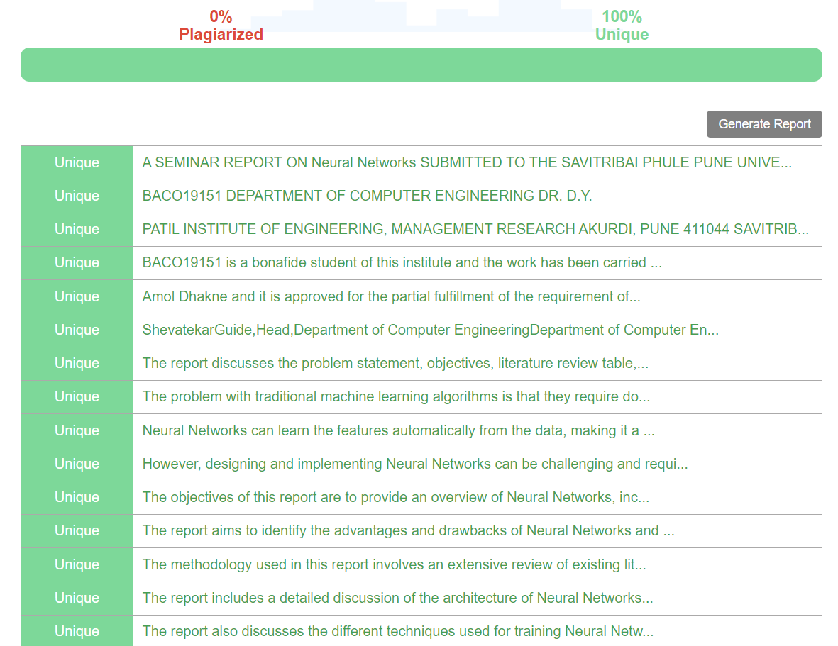

Seminar Log Book

Record of Seminar Review with Guides

Sr. No. | Date | Details of Discussion/ Remark | Signature of Guide
1. | 09/02/2023 | Title Submission | Mr. Shivaji Vasekar
2. | 23/02/2023 | Base Paper Submission | Mr. Shivaji Vasekar
3. | 09/03/2023 | Synopsis formation & submission | Mr. Shivaji Vasekar
4. | 16/03/2023 | PPT checking | Mr. Shivaji Vasekar
5. | 23/03/2023 | Seminar Report Checking | Mr. Shivaji Vasekar
6. | 13/04/2023 | Seminar Report finalization & Paper Writing | Mr. Shivaji Vasekar
7. | 27/04/2023 | Final PPT Submission & Paper Publication | Mr. Shivaji Vasekar


